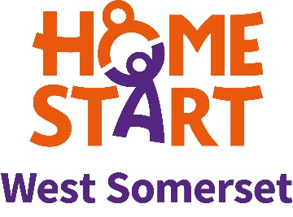
HOME-START WEST SOMERSET
HERE TO HELP YOU AT THIS DIFFICULT TIME IF YOU ARE A FAMILY WITH YOUNG CHILDREN UNDER SEVEN AND NEED HELP OR SUPPORT.

WE CAN OFFER THE FOLLOWING

EMOTIONAL SUPPORT AND FRIENDSHIP
IDEAS FOR FAMILY ACTIVITIES DURING “LOCK DOWN”
BUMP-START AND ANTENATAL SUPPORT
ONLINE ANTENATAL WORKSHOPS
FOODBANK DELIVERIES

IF YOU WOULD LIKE MORE INFORMATION PLEASE CONTACT US VIA OUR FACEBOOK PAGE, BY EMAIL admin@homestart-westsomerset.org.uk
OR BY TELEPHONE 01643 707304 WHEN WE WILL GET BACK TO YOU AS SOON AS POSSIBLE
